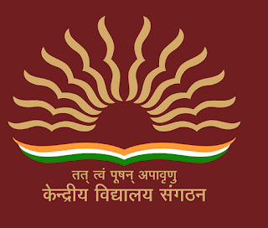
KV AAI RANGPURI
CMP Newsletter 2019-20(IInd Term)

Principal’s Message :
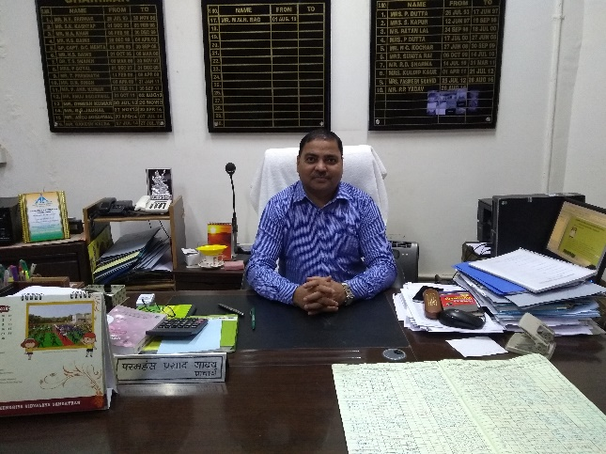
Kendriya Vidyalaya Sangathan is known for imparting quality education be its academic or co-curricular activities. We as a team are making our best effort to give quality education to our students. Our staff fruitfully employ two diverse strategies that are of Love and Logic to foster a positive learning environment for all our little bloomers. I hope this newsletter strive to showcase the talents of our blooming buds and multi skilled teachers.
Mr. Paramhans Prasad Yadav
Headmistress’ Message :
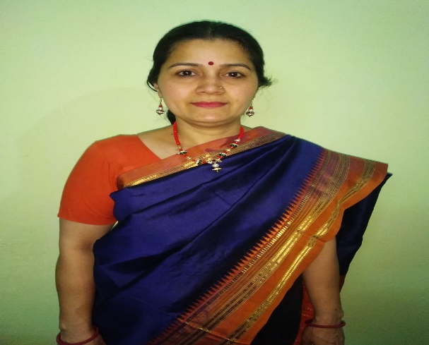
We realise the fact that all students have different talents so the success of each student will reflect differently. We try to incorporate such activities that helps the all round development of each child. The students in our school are offered many opportunities to explore their interests and investigate new ideas.
Mrs. Dimple Balodi
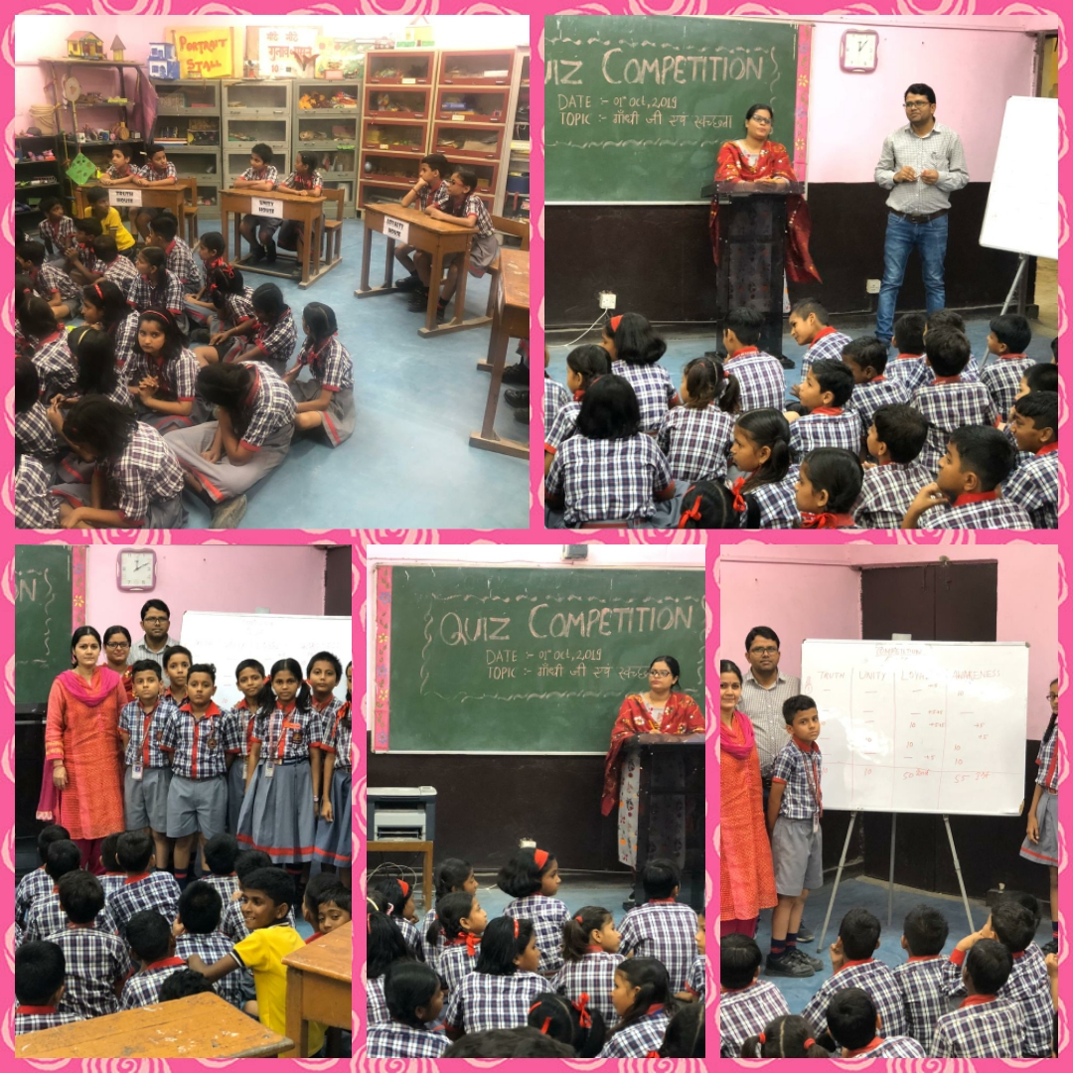
QUIZ COMPETITION ON MAHATMA GANDHI (01-10-2019)
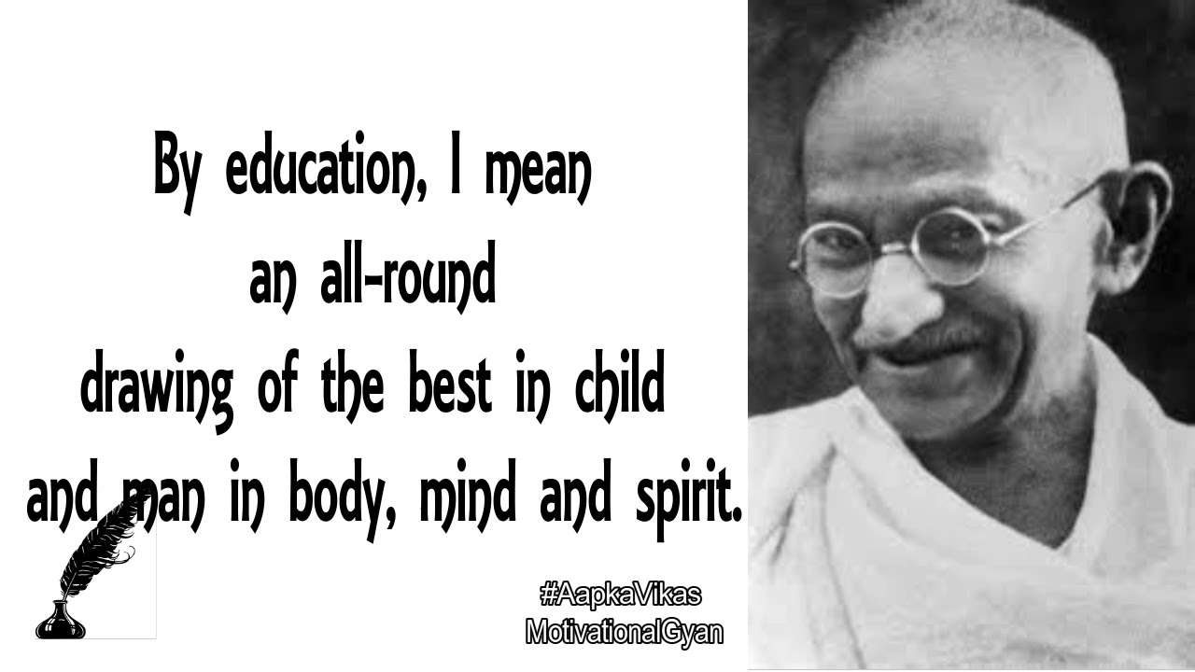
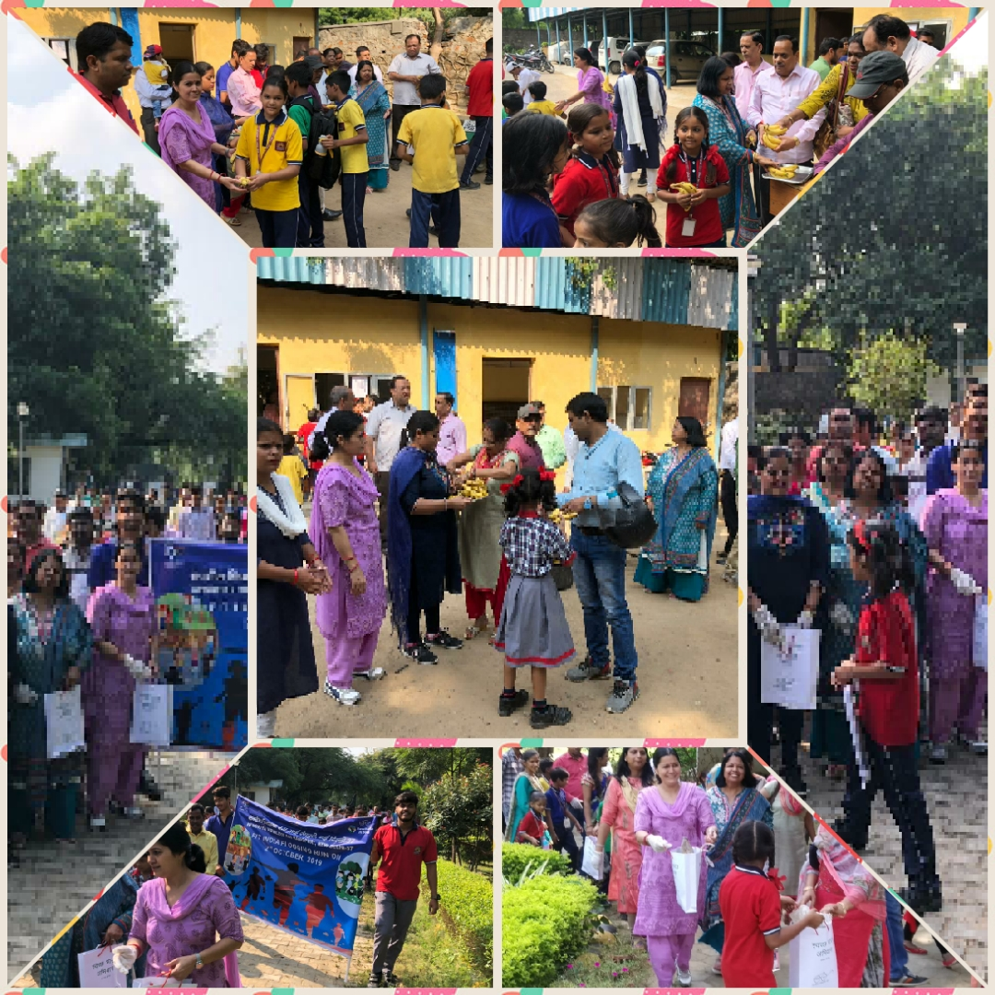
PLOG RUN (02-10-2019)
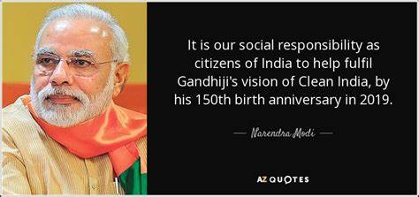

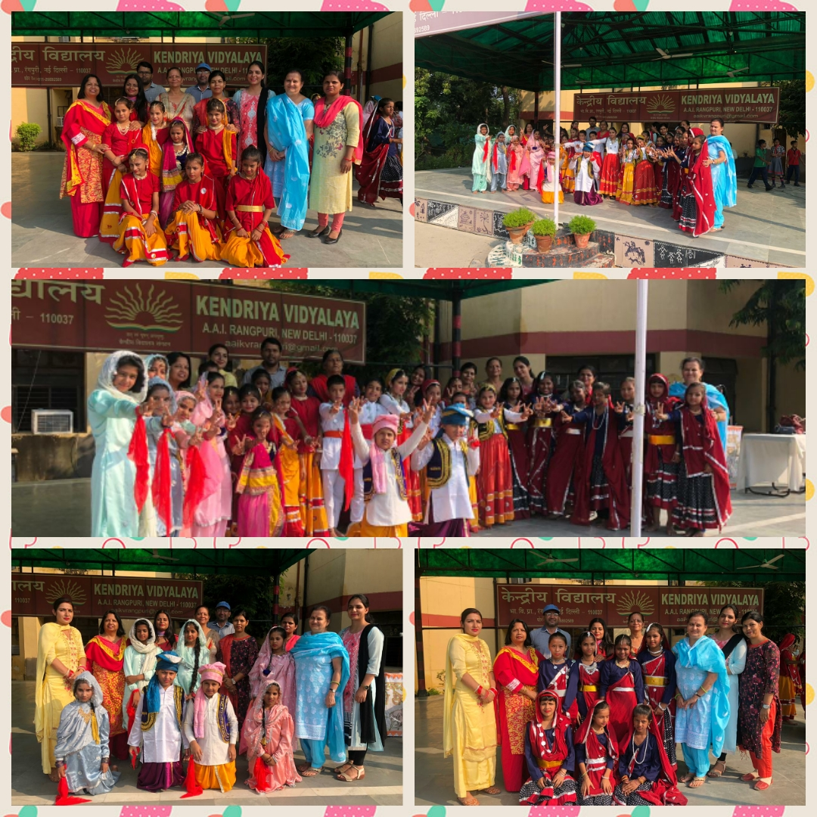
GROUP DANCE (04-10-2019)
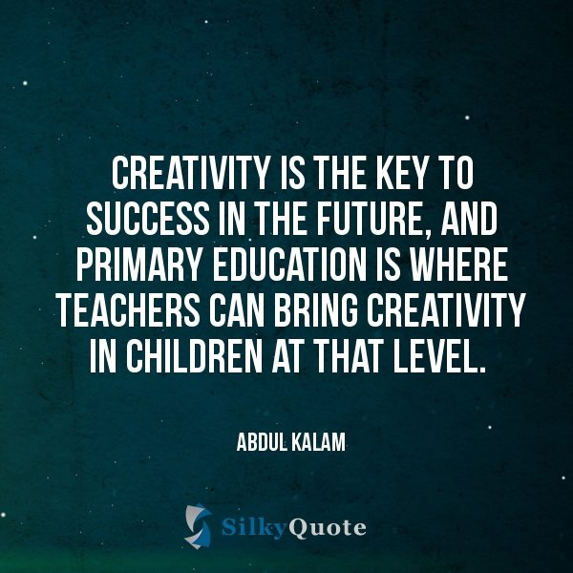

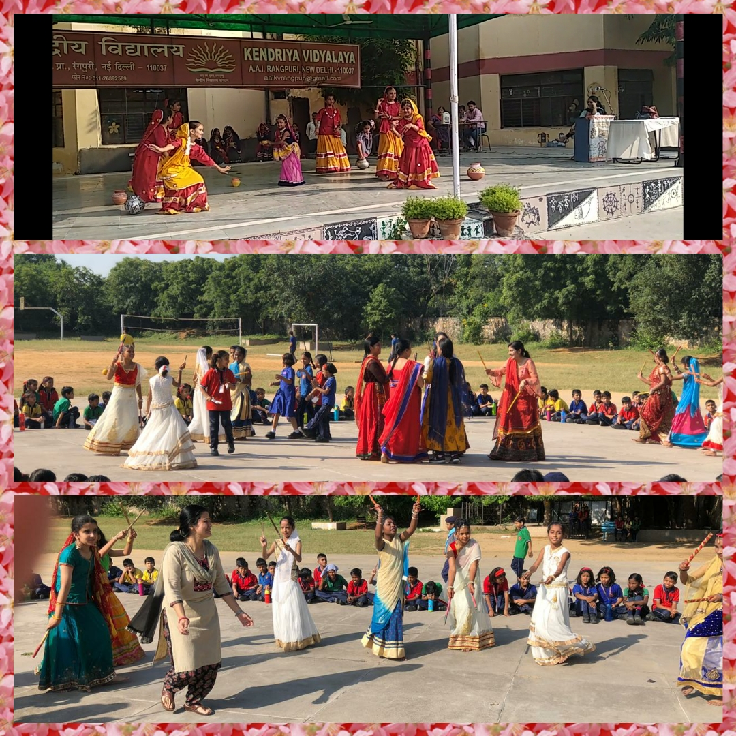
JANMASHTMI AND NAVRATRI CELEBRATION (05-10-2019)
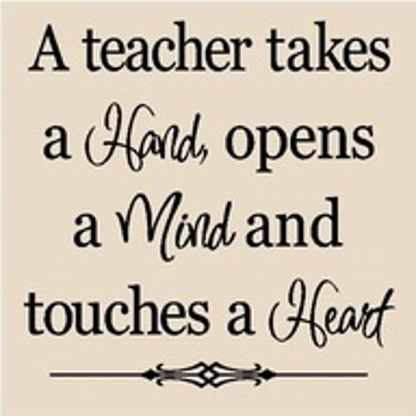

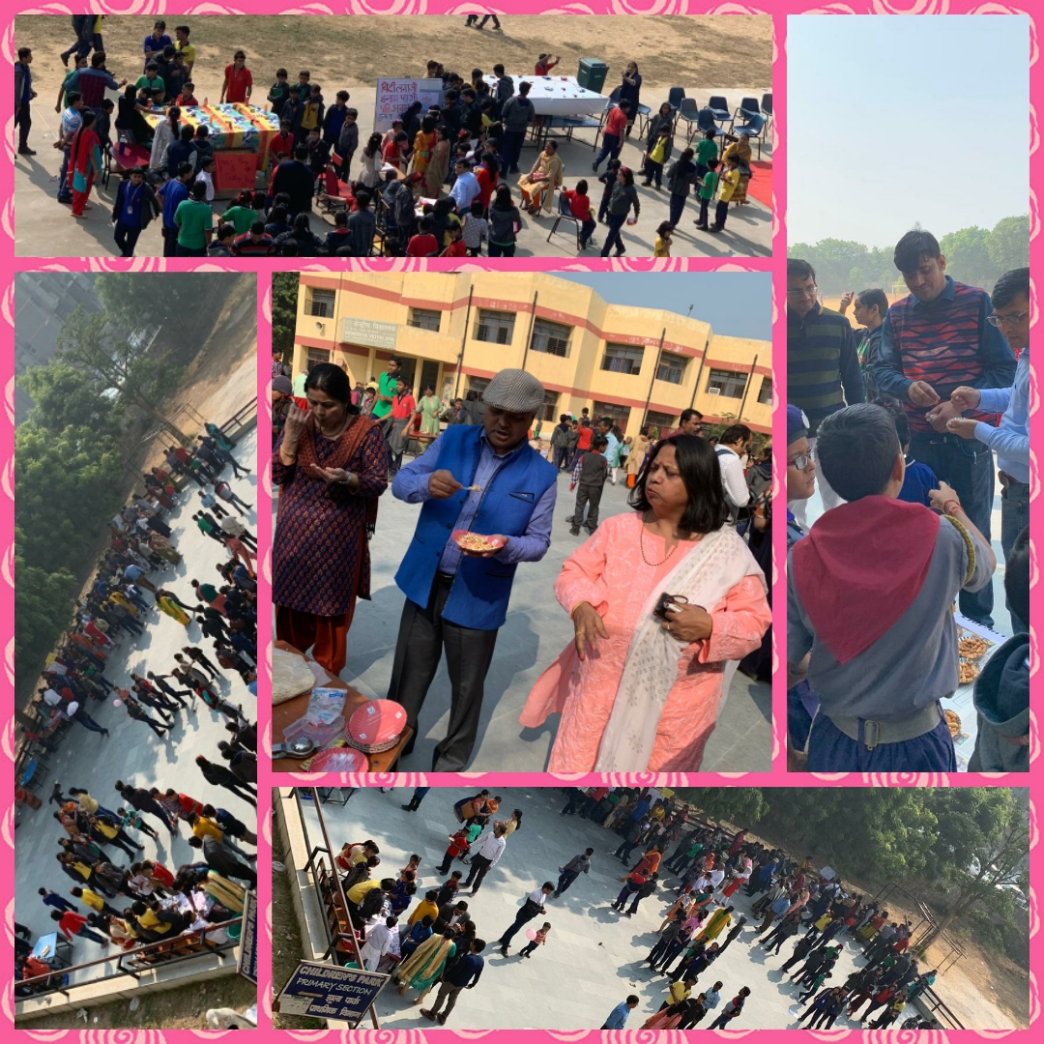
BAL MELA (16-11-2019)
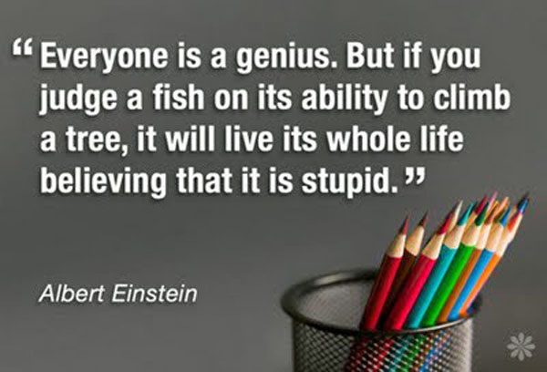

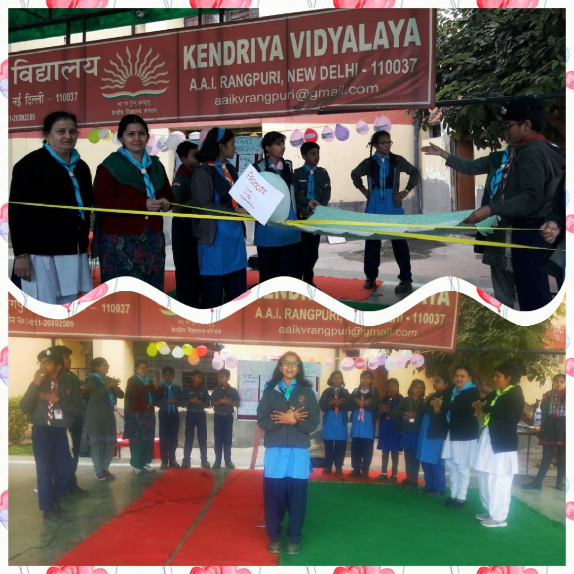
MESSENGER OF PEACE (12-12-2019)

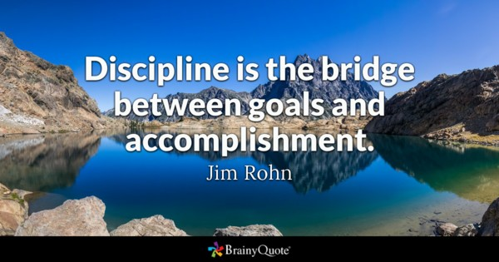
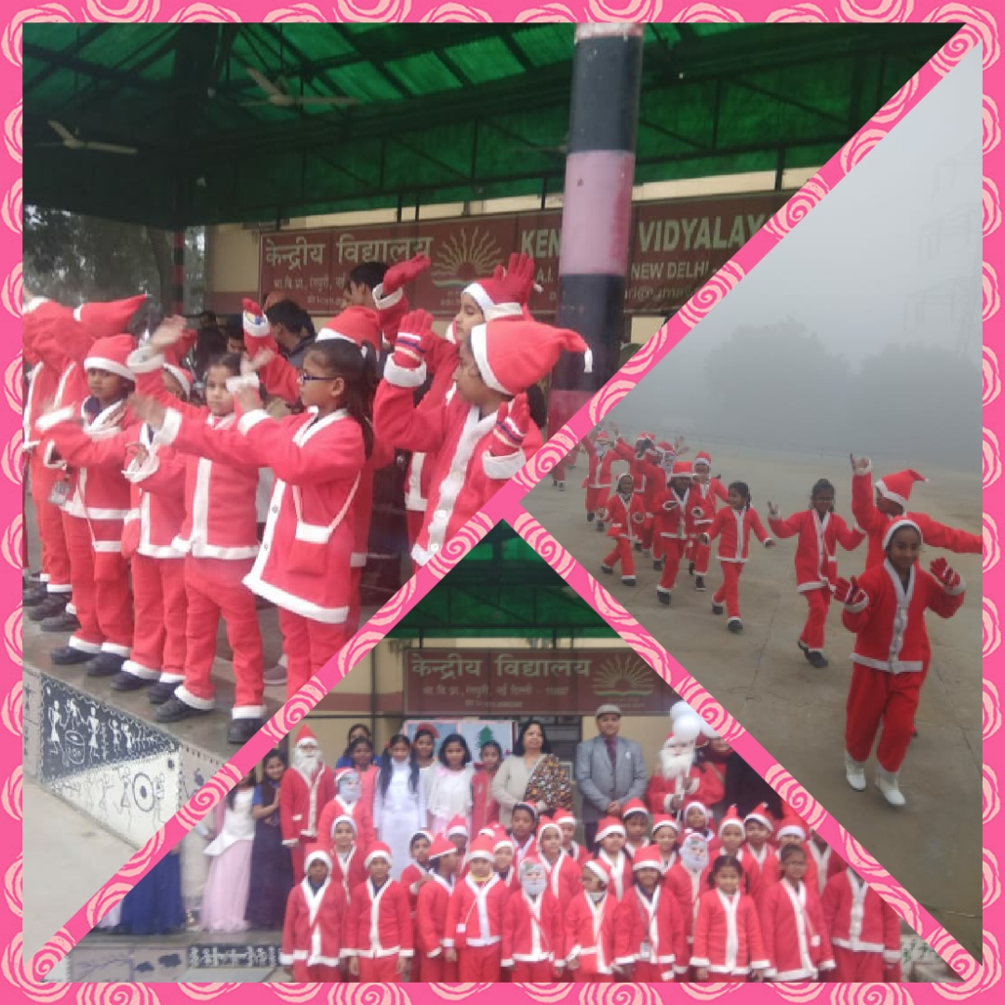
CHRISTMAS DAY CELEBRATION (21-12-2019)

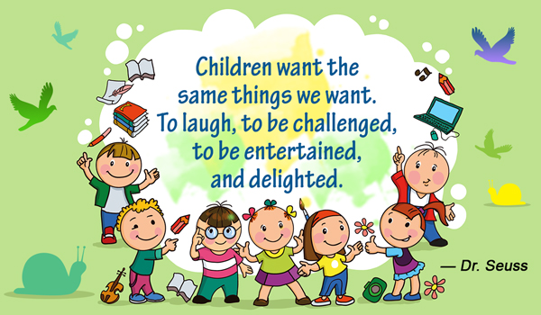

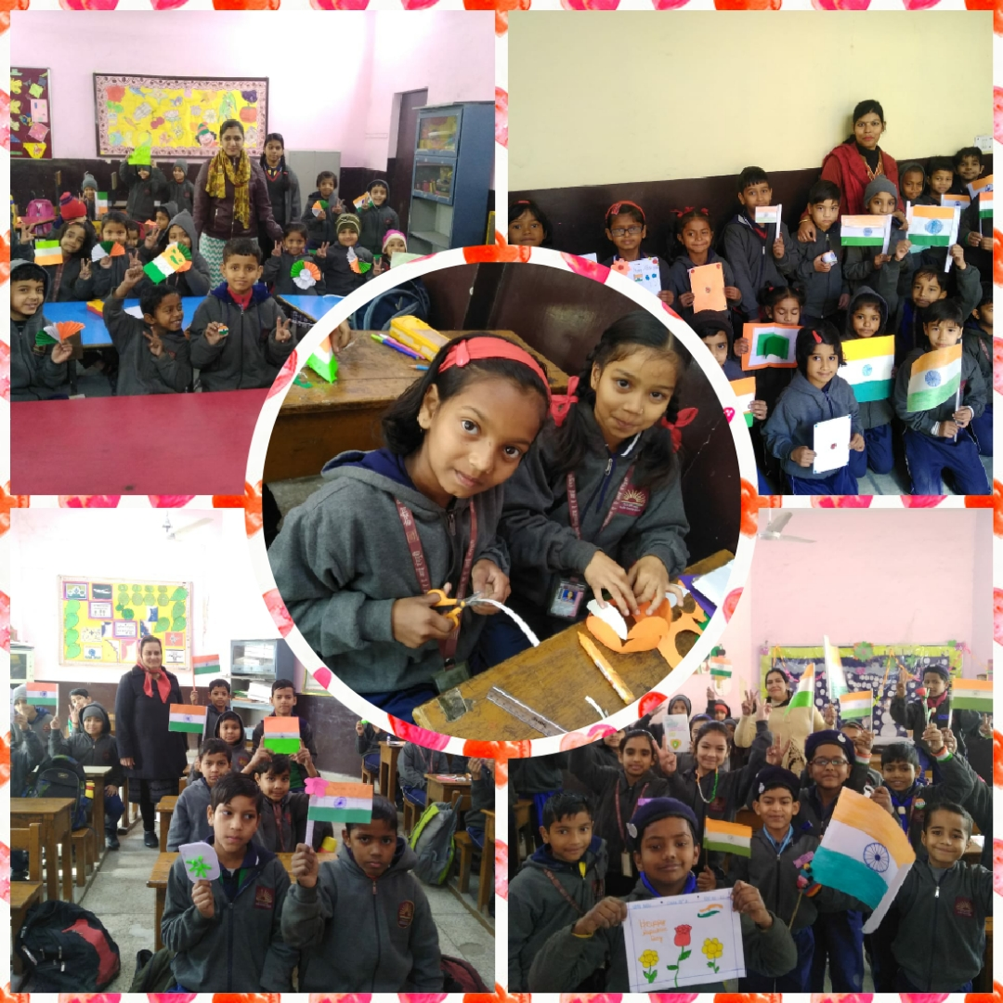
FLAG MAKING (25.01.2020)

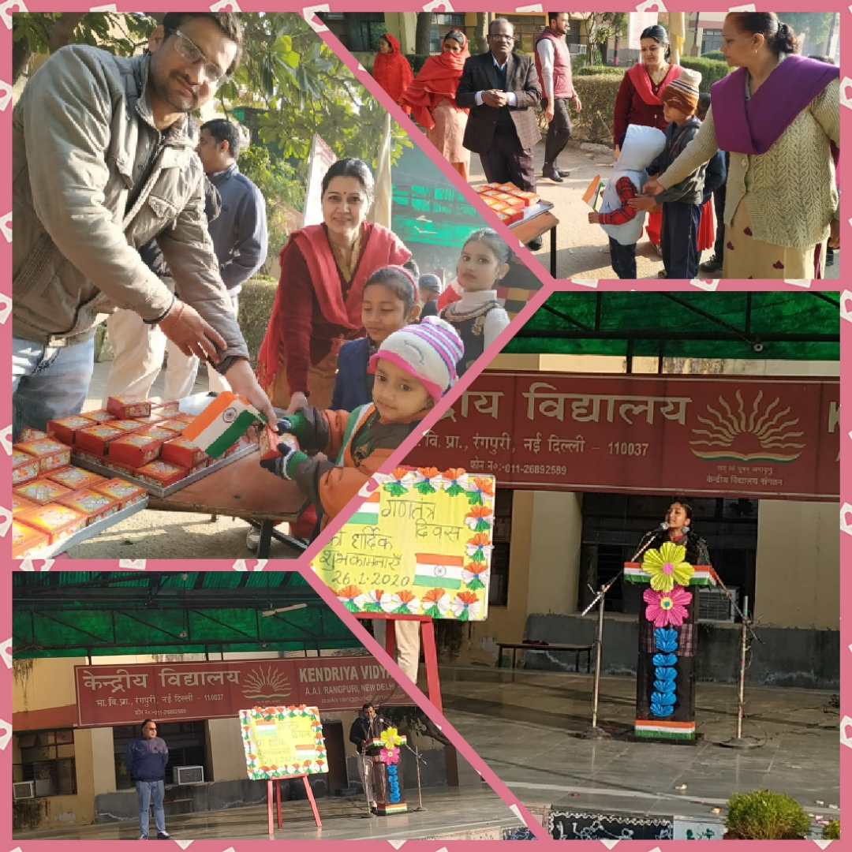
REPUBLIC DAY CELEBRATION (26.01.2020)
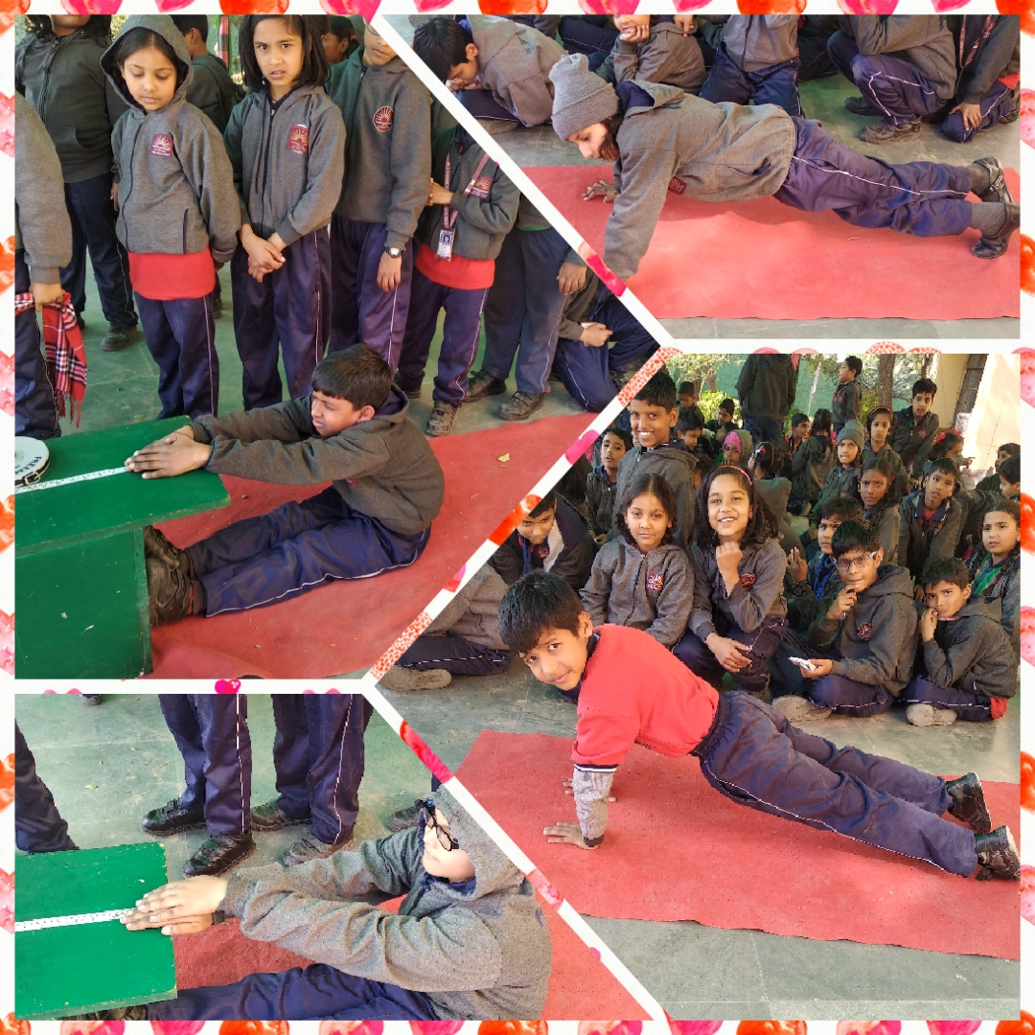
SBSB ACTIVITIES
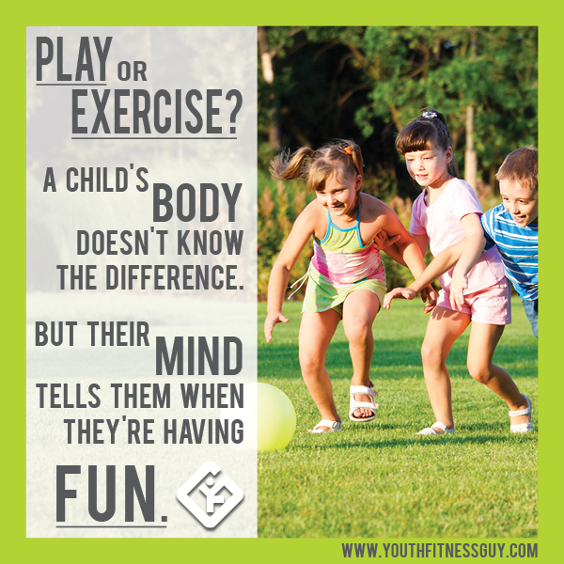

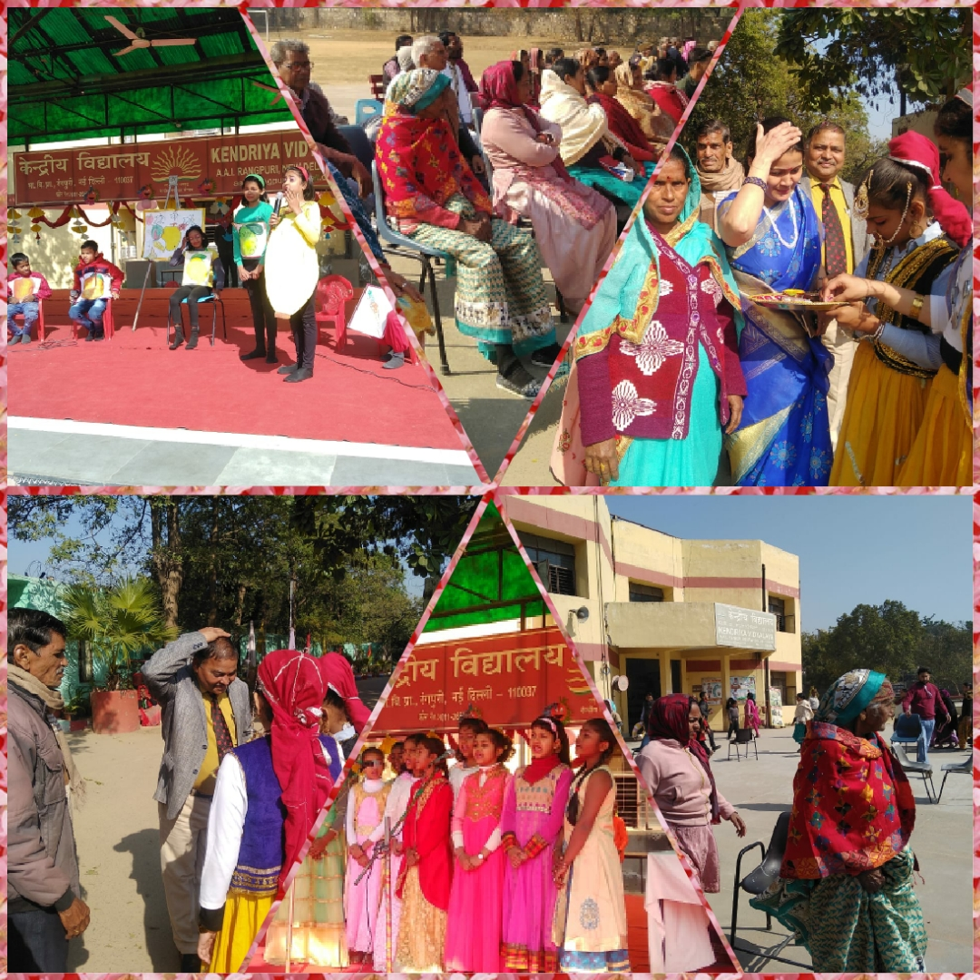
GRANDPARENTS DAY CELEBRATION (13-02-2020)
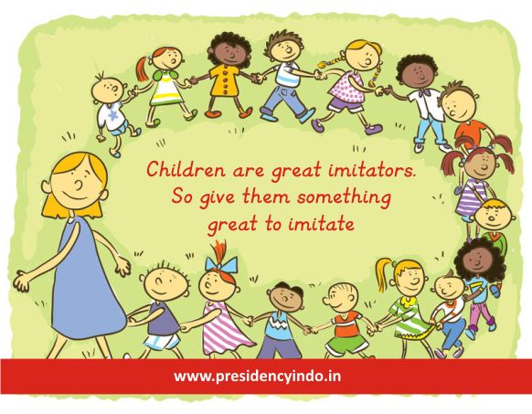

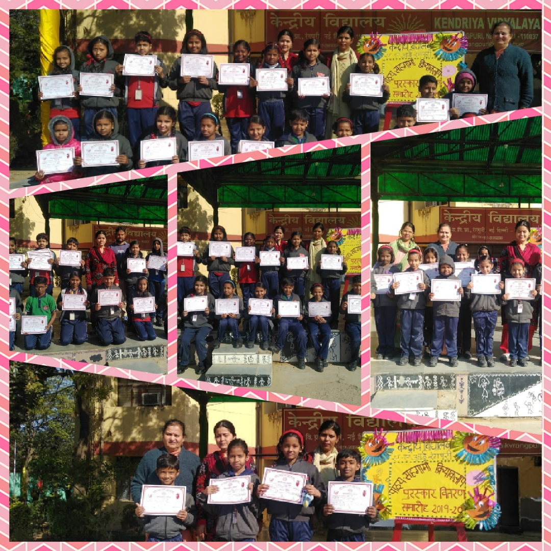
CCA CERTIFICATE DISTRIBUTION (15-02-2020)
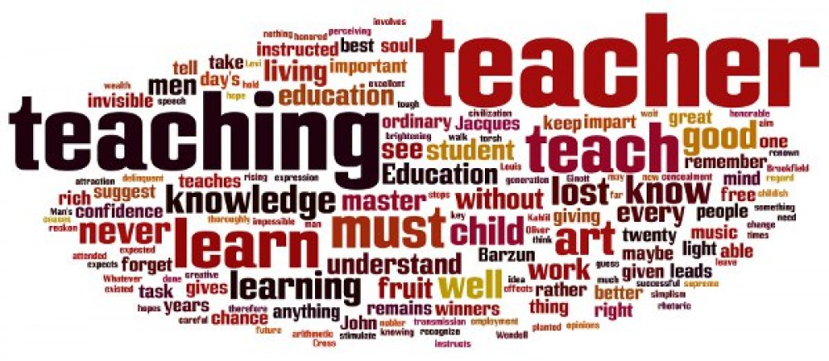

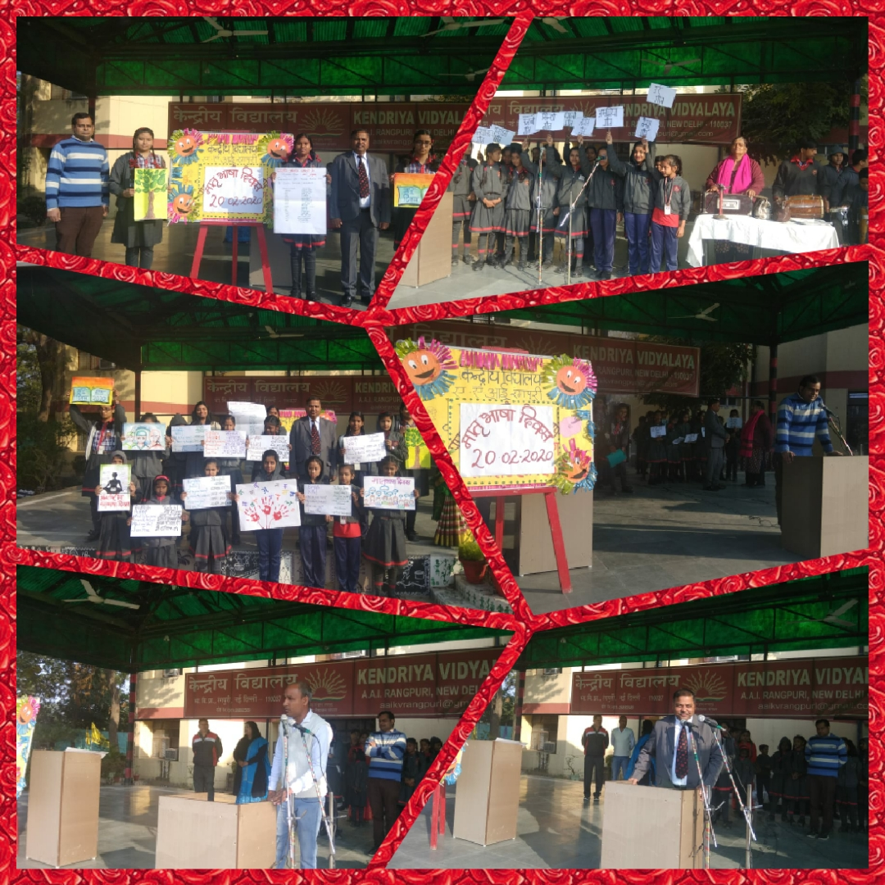
MATRABHASHA DIWAS (20-02-2020)
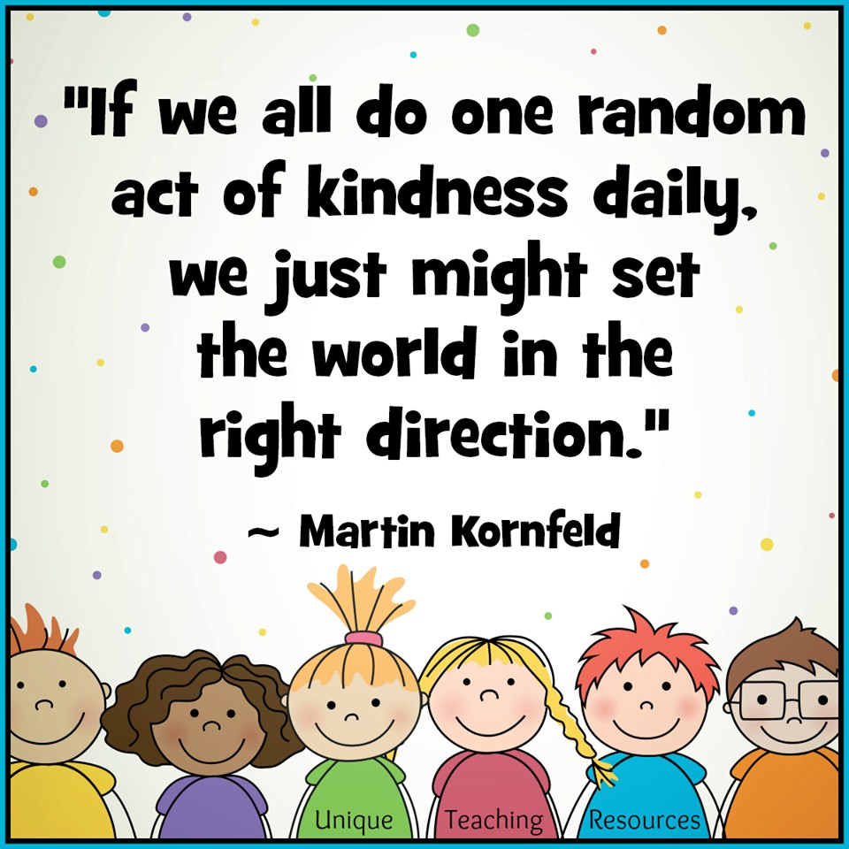

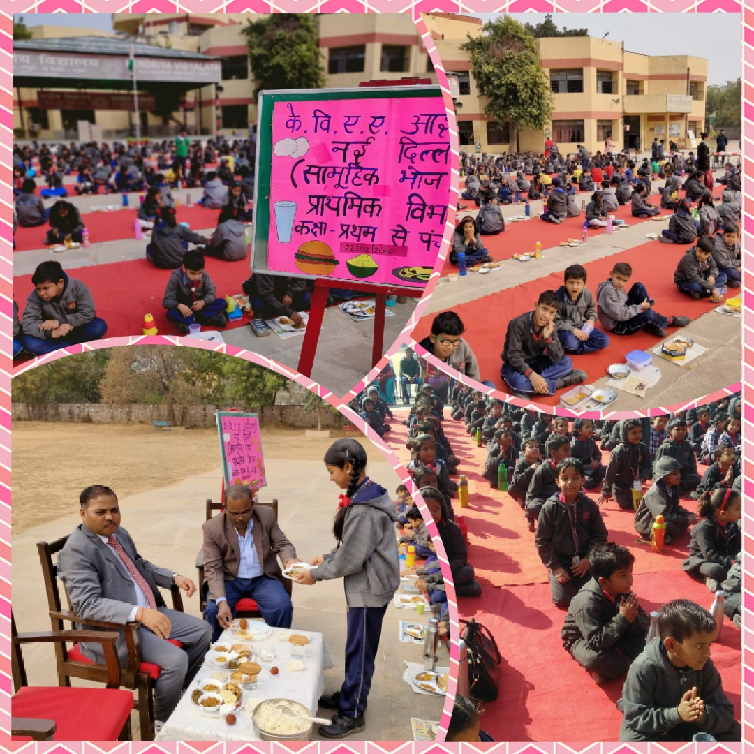
COMMUNITY LUNCH (22-02-2020)
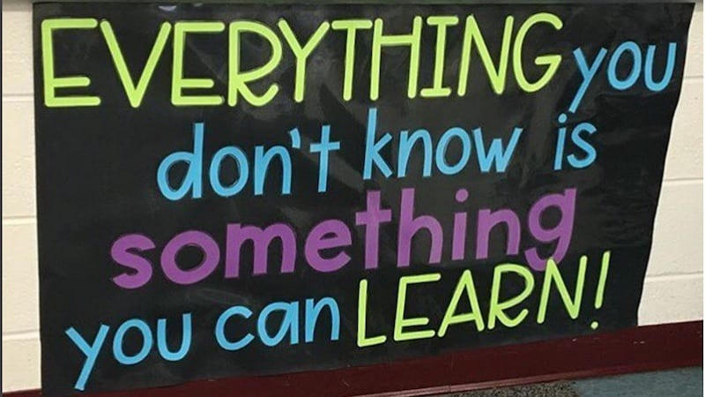
Editorial Board
Patron: Mr. P. P. Yadav, Principal
Advisor: Mrs. Dimple Balodi, Headmistress
Photography: Mrs. Ritu
Editing & Layout: Mrs. Babita, Mrs. Ritu Chahal
Design & Creation: Mr. Rahul Verma

